BACHKHOA-APTECH COMPUTER EDUCATION CENTER



Furniture Management System

Group 4 – C1212L – Bachkhoa-aptech
Group Member | Name | Roll No
Group Member | Trịnh Văn Đồng (leader)  Nguyễn Vũ Hồng Kỳ  Nguyễn Minh Hải
Instructor | Mr. Nguyễn Hùng Cường

Table of Contents

ACKNOWLEDGEMENT…………………………………………………………...………3
1. Problem Definition 4
1.1. Introduction 4
1.2. Functional components of the project 4
1.3. Hardware and Software Requirements 7
2. Customer Requirements Specification 8
2.1. Users of the System 8
2.2. System functions 8
3. Architecture & Design of the Project 12
3.1 Architecture 12
3.2. Usecase Diagram 13
3.3. Sequence Diagram 15
3.4. Entity Relationship (ER) Diagram 31
3.5. Database Design/Structure 32
4. Algorithms 37
5. Snapshot………………………………………………………………………………... 42
6. Task Sheet 44

7. Checklist of validations……………………………………………..………………….. 45
8. Submission Checklist………………………………………………..…………………..45

ACKNOWLEDGEMENT
We would like to acknowledge all those who have given support and help us make the project a success.

We wish to express our deep gratitude to all teachers who have been devoting their lives to teach us how to stand-alone and walk ahead.

We are grateful to our families who take care and encourage us even though we are successful or failed, also to our friends who are always care of us. They never leave us alone and always look forward to us when we are on any road of the life.

We are much thankful to the entire staff and chairmen at the Head Office of Aptech Worldwide, Aptech – Vietnam, and Bachkhoa – Aptech center who have been organizing and looking after our studying course.

Our special thanks to Mr.Nguyen Hung Cuong who works day by day to teach and guide us in our travel to discover the wonder of Java Programming Language. Also to mentor in eProject Team at the Head Office who instruct and help us.

Finally, we would like to offer many thanks to all our schoolfellows for their valuable suggestions.

We would like to thank sincerely!

Group 4 – C1212L

Problem Definition

Introduction:

Fair Deal is a Furniture shop which sells different types of furniture for home, offices, hospital etc. Earlier the shop use to manufacture selected items but with the increasing response of the customer and their demand they have added items related to office, hospital etc. So it becomes difficult to manage all the order detail, price, employees’ details etc. So the owner of the shop decided to develop software for his furniture shop. So the software FURNITURE SYSTEM has to be developed to automate the shop. This includes information about all products available, their price orders and employees. This system gives a generalize, concise and accurate information regarding billing, purchase details. Stock etc. This system provides any type of enquiry such as product details, stock, purchase details, order details, billing etc.

Functional components of the project:
I. Working Application
a. Source Code
b. Compiled Code

II. eProject Report
n eProject Report should comprise
q Acknowledgements
q eProject Synopsis
q eProject Analysis
q eProject Design
n DFD’s
n FlowCharts
n Process Diagrams
n Database Design / Structure
q Screen Shot’s
q Source Code with Comments
q User Guide
q Developer’s Guide
n Module Descriptions

- User Guide means User Manual, it should have details how a user can operate the application.
- Developer’s Guide should have detail description of the modules, so that any developer can look into the code and get to know about it through the Developer’s Guide.

Hardware and Software Requirements

 | Client | Server
Hardware | - CPU Pentium IV, 1.2 MHz (or better)  - 512 Megabytes of RAM (or better) | - CPU Pentium IV, 2.0 MHz (or better)  - 1024 Megabytes of RAM (or better)
Software | - Windows xp (or higher)  - NetBeans IDE 7.2.1 | - SQL Server 2005  - NetBeans IDE 7.2.1

Customer Requirements Specification

Users of the System
- Admin
- Employee

System functions

Admin:
- Login

Description | To allow the admin login.
Input | Username and password.
Process | Check username and password in database.
Output | Display the result login.

- User Management.

Description | Admin can change password and information.
Input | Information, password of user.
Process | Insert, update or delete information, password into database.
Output | Display message box successful or unsuccessful.

- Employee Management

Description | Admin can search, view, add, edit and delete employee.
Input | Information of employee.
Process | Insert, update or delete information into database.
Output | Display message box successful or unsuccessful.

- Product Management

Description | Admin can add, edit, delete, search and view product.
Input | Information of product.
Process | Insert, update or delete information into database.
Output | Display message box successful or unsuccessful

- Vendor Management.

Description | Admin can add, edit, delete, search and view vendor
Input | Information of vendor
Process | Insert, update or delete information into database.
Output | Display message box successful or unsuccessful.

- Pucharse, Order Management.

Description | Admin can add, edit, delete, search and view purchase, order details
Input | Purchase, order details
Process | Insert, update or delete information into database.
Output | Display message box successful or unsuccessful.

- Report Management.

Description | Admin can search, view and print report
Input | Information of report
Process | Create report from database.
Output | Display report.

- Log out.

Description | To allow the admin logout.
Input | Action to logout.
Process | Escape from program's system.
Output | Display message and back to login form.

Employee:
- Login

Description | To allow the employee login.
Input | Username and password.
Process | Check username and password in database.
Output | Display the result login.

- User managment

Description | Employee can change password and information
Input | Information, password of user.
Process | Insert, update or delete information, password into database.
Output | Display message box successful or unsuccessful.

- Product Management

Description | Employee can add, edit, delete, search and view product.
Input | Information of product.
Process | Insert, update or delete information into database.
Output | Display message box successful or unsuccessful

- Vendor Management.

Description | Employee can add, edit, delete, search and view vendor
Input | Information of vendor
Process | Insert, update or delete information into database.
Output | Display message box successful or unsuccessful.

- Pucharse, Order Management.

Description | Employee can add, edit, delete, search and view purchase, order details
Input | Purchase, order details
Process | Insert, update or delete information into database.
Output | Display message box successful or unsuccessful.

- Log out.

Description | To allow the employee logout.
Input | Action to logout.
Process | Escape from program's system.
Output | Display message and back to login form.

Architecture & Design of the Project

Architecture

Presentation-Layer

Middle-Layer

Data Access Layer
User interface with Swings forms

Business Logic components

Data Access Objects

3-Layer Architecture of the Project

Usecase Diagram

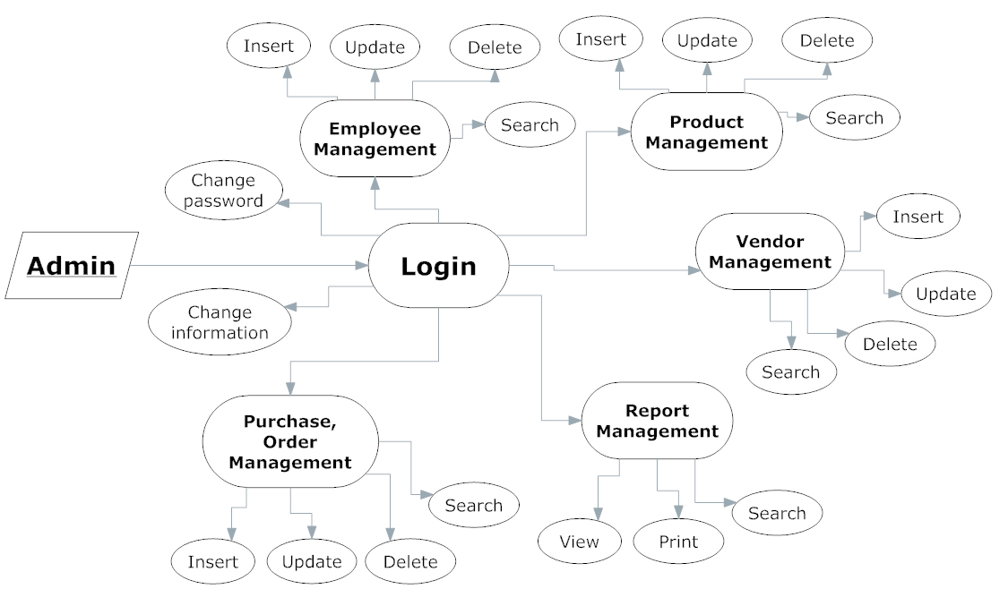

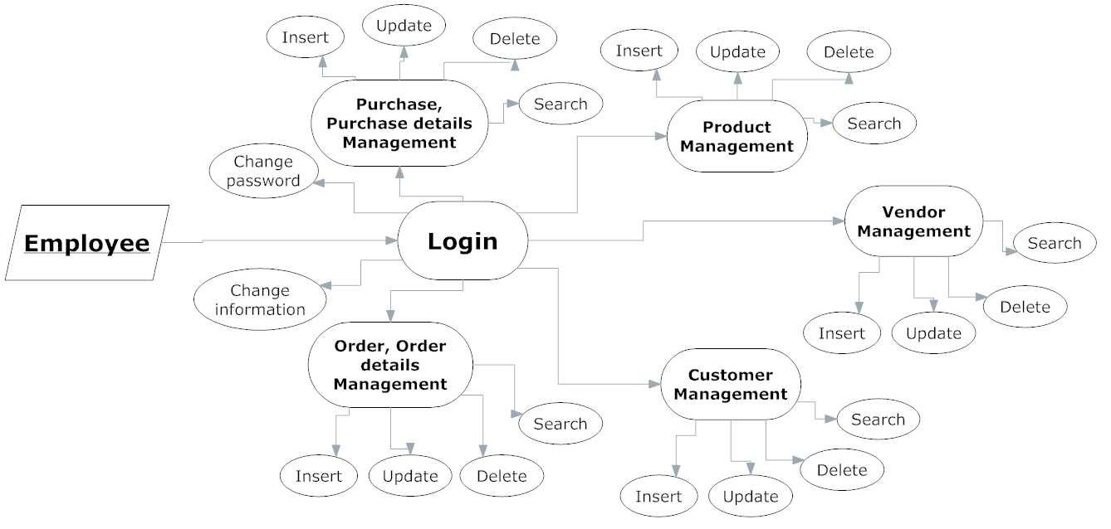

Entity Relationship (ER) Diagram

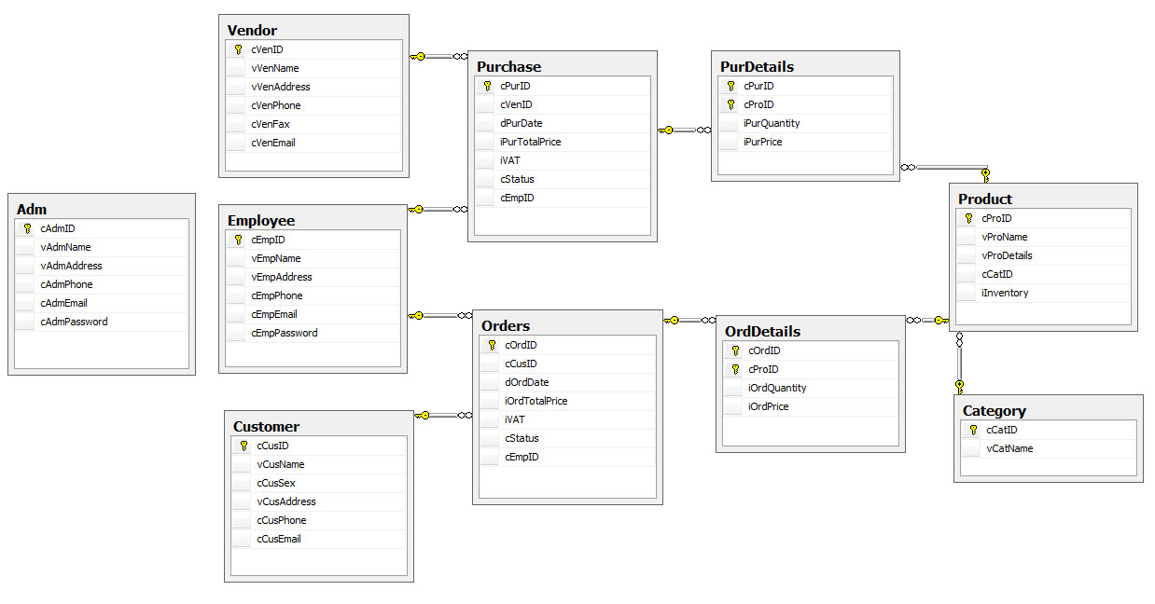

Database Design/Structure

Table Design

Adm
Fields | Data Type | Is Null | References | Description
cAdmID | Char(6) | No | Primary Key | Admin ID
vAdmName | Varchar(50) | No |  | Admin name
vAdmAddress | Varchar(100) | No |  | Admin address
cAdmPhone | Char(15) | No |  | Admin phone number
cAdmEmail | Char(50) | No |  | Admin email
cAdmPassword | Char(50) | No |  | Admin password

Category
Fields | Data Type | Is Null | References | Description
cCatID | Char(6) | No | Primary Key | Category ID
vCatName | Varchar (50) | No |  | Category name

Customers
Fields | Data Type | Is Null | References | Description
cCusID | char(6) | No | Primary Key | Customer ID
vCusName | varchar(50) | No |  | Customer name
cCusGender | char(6) | No |  | Customer gender
vCusAddress | varchar(100) | No |  | Customer address
cCusPhone | char(15) | No |  | Customer phone number
cCusEmail | char(50) | No |  | Customer email

Employee
Fields | Data Type | Is Null | References | Description
cEmpID | char(6) | No | Primary Key | Employee ID
vEmpName | varchar(50) | No |  | Employee name
vEmpAddress | varchar(100) | No |  | Employee address
cEmpPhone | char(15) | No |  | Employee phone number
cEmpEmail | char(50) | No |  | Employee email
cEmpPassword | char(50) | No |  | Employee password

Orders
Fields | Data Type | Is Null | References | Description
cOrdID | char(6) | No | Primary Key | Orders ID
cCusID | char(6) | No |  | Customer ID
dOrdDate | Datetime | No |  | Orders date
iOrdTotalPrice | Int | No |  | Orders total price
iVAT | Int | No |  | Orders VAT
cStatus | char(100) | No |  | Orders status
cEmpID | char(6) | No |  | Employee ID

OrdDetails
Fields | Data Type | Is Null | References | Description
cOrdID | char(6) | No | Order | Order ID
cProID | char(6) | No | Product | Product ID
iOrdQuantity | Int | No |  | Order quantity
IOrdPrice | Int | No |  | Order price

Product
Fields | Data Type | Is Null | References | Description
cProID | char(6) | No | Primary Key | Product ID
vProName | Datetime | No |  | Product name
vProDetails | Int | No |  | Product details
cCatID | char(100) | No | Category | Category ID
iInventory | char(6) | No |  | Product inventory

Purchase
Fields | Data Type | Is Null | References | Description
cPurID | char(6) | No | Primary Key | Purchase ID
cVenID | Int | No | Vendor | Vendor ID
dPurDate | Datetime | No |  | Purchase date
iPurTotalPrice | Int | No |  | Purchase total price
iVAT | Int | No |  | Purchase VAT
cStatus | char(100) | No |  | Purchase status
cEmpID | char(6) | No | Employee | Employee ID

PurDetails
Fields | Data Type | Is Null | References | Description
cPurID | char(6) | No | Purchase | Purchase ID
cProID | char(6) | No | Product | Product ID
iPurQuantity | Int | No |  | Purchase quantity
iPurPrice | Int | No |  | Purchase price

Vendor
Fields | Data Type | Is Null | References | Description
cVenID | char(6) | No | Primary Key | Vendor ID
vVenName | nvarchar(50) | No |  | Vendor name
vVenAddress | varchar(100) | No |  | Vendor address
cVenPhone | char(15) | No |  | Vendor phone number
cVenFax | char(15) | No |  | Vendor fax
cVenEmail | char(50) | No |  | Vendor email

4. Algorithms

Flow chart 1: Login

Begin
Input user name and password
End
Try again?
False
Yes
No
User exists and password match

Access application
True

Flow chart 2: Add new a record

Begin

Input fields

Validate data

Save to database

Message
End
False
True

Flow chart 3: Update a record

Begin

Input data

Validate data

Save to database

Message
End
False
True

Flow chart 4: Delete a record

Begin
Choose record to delete
Validate data

Save to database

Message
End
False
True

Flow chart 5: Search a record

Begin
Input
data to search
Validate
Display result
End
Try again?
No
Yes
False
True

5. Snapshot

Login Page

Admin Home

Interviewer Home

6. Task Sheet

Project Ref.No.: |  | Project Title | Active Plan Prepared By: | Date Of Preparation Of Activity Plan:
Sr.No | Task | Project Title | Active Plan Prepared By: | Actual Start  Date | Actual  Days |  | Team Member  Name |  | Status
Document & GUI
1 | Analyze System | Recruitment Process System | Group 3 | 28/08/2013 | 10 days |  |  | Group | Completed
2 | Design Database | Recruitment Process System | Group 3 | 07/09/2013 | 3 days |  |  | Group | Completed
3 | Report (I) | Recruitment Process System | Group 3 | 10/09/2013 | 5 days |  |  |  | Completed
4 | Design and Develop GUI | Recruitment Process System | Group 3 | 15/09/2013 | 5 days |  |  |  | Completed
5 | Report (II) | Recruitment Process System | Group 3 | 20/09/2013 | 4 days |  |  |  | Completed
Coding
6 | Employee Management | Recruitment Process System | Group 3 | 24/09/2013 | 4 days |  |  |  | Completed
7 | Department  Management | Recruitment Process System | Group 3 | 28/09/2013 | 4 days |  |  |  | Completed
8 | Vacancy Management | Recruitment Process System | Group 3 | 02/10/2013 | 4 days |  |  |  | Completed
9 | Applicant Management | Recruitment Process System | Group 3 | 06/10/2013 | 4 days |  |  |  | Completed
10 | Applicant -Vacancy | Recruitment Process System | Group 3 | 10/09/2012 | 4 days |  |  |  | Completed
11 | Interview Management | Recruitment Process System | Group 3 | 15/09/2012 | 4 days | Group |  |  | Completed

7. Checklist of Validations

Option | Validated
Can a new user who gets registered, enter the application after logged in? | Yes
Do all the options present in the application display the correct result? | Yes
Does the application’s functionality resolve the user problem, and satisfy their needs? | Yes
Has the hardware and software been correctly chosen? | Yes

8. Submission Checklist

Sr.No | Particular | Yes | No | NA | Comment
1 | Are you users able to login to the application after validation is performed on the user name and password? | Yes
2 | Are the users able to modify their details after getting registered? | Yes
3 | Are all the screen contents devoid of spelling mistakes? | Yes
4 | Is the user able to trade on fund which has been selected? | Yes
5 | Is the application user-friendly? | Yes

